|  |
| --- |
|  |
|  |
| **Website Check List** |
| Go to this link to Check Out the website:  <http://teamrecon.nayeem.co/board/>  UN: board  PW hamster  Red – Accomplished 03/03/12 |
|  |

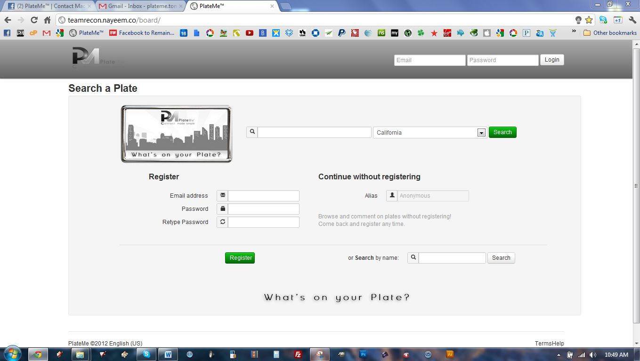

|  |
| --- |
| This document is confidential and intended for its addressee(s) only, and may contain information which is privileged, confidential, and exempt from disclosure by law. For any reader who is not the intended recipient, any dissemination, distribution, or copying is prohibited, and request is herein made to notify the sender immediately by telephone and/or email reply. All information in this document belongs to the PlateMe Corporation. Misdirected delivery of this communication is not intended to waive privilege or to make public otherwise confidential information. |

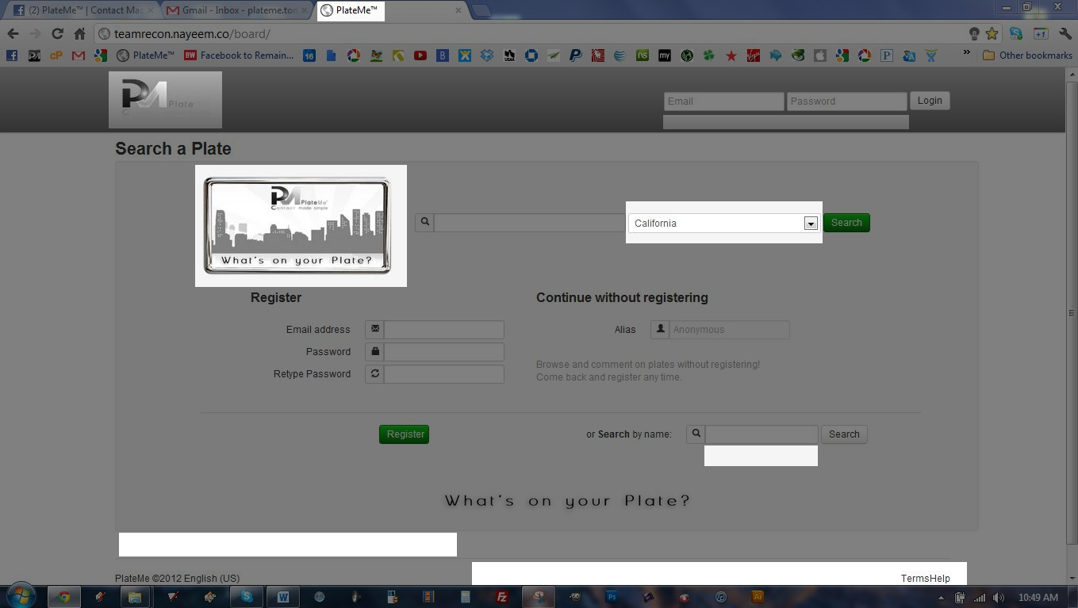

**Landing Page**

1. **URL**
   1. Insert Favicon
   2. PlateMeTM | Contact Made Simple
2. **Header**
   1. Change header back to original color
   2. Log In
      1. Already a Member?
      2. Keep me Logged In
      3. Allow Click Enter to Log In
3. **Search a Plate**
   1. Change License Plate to coincide with State Selection
   2. Allow all 50 states plus PM Generic Plate
   3. Use Real Time Photo Manipulation when searching a plate
      1. Update Plate Font
      2. Match Font Color with States
4. **Continue without Registering** 
   1. Click Anonymous
      1. Take user to PlateMe Anonymous Profile
      2. Display “Local News” in feed
5. **Search by Name**
   1. Add feature: More Search Options
6. **Footer**
   1. Insert the 16 Languages we will be launching in
   2. Mobile – Pages – About – Advertising – Developers – Careers – Privacy – Terms – Help
7. **Other Notes**
   1. The Page gets way out of whack when you chose half screen view, this needs to be fixed
   2. How do I register a Plate? Searching will create a plate if it doesn’t exist. User can “claim plate”
8. **Misc Backend changes**
   1. Bug that doesn’t allow the user’s account information to be updated correctly.
   2. Fix ordering of posts and comments
   3. Plate image generation too slow
      1. Use PNG instead of JPG
      2. Create images in memory rather than store to disk
      3. Make background of text transparent
   4. Bug in average 5 star ratings
      1. Seems to be only working sometimes
   5. Bug which allowed “deleted” posts to still be shown
   6. Add latitude and longitude

|  |
| --- |
|  |

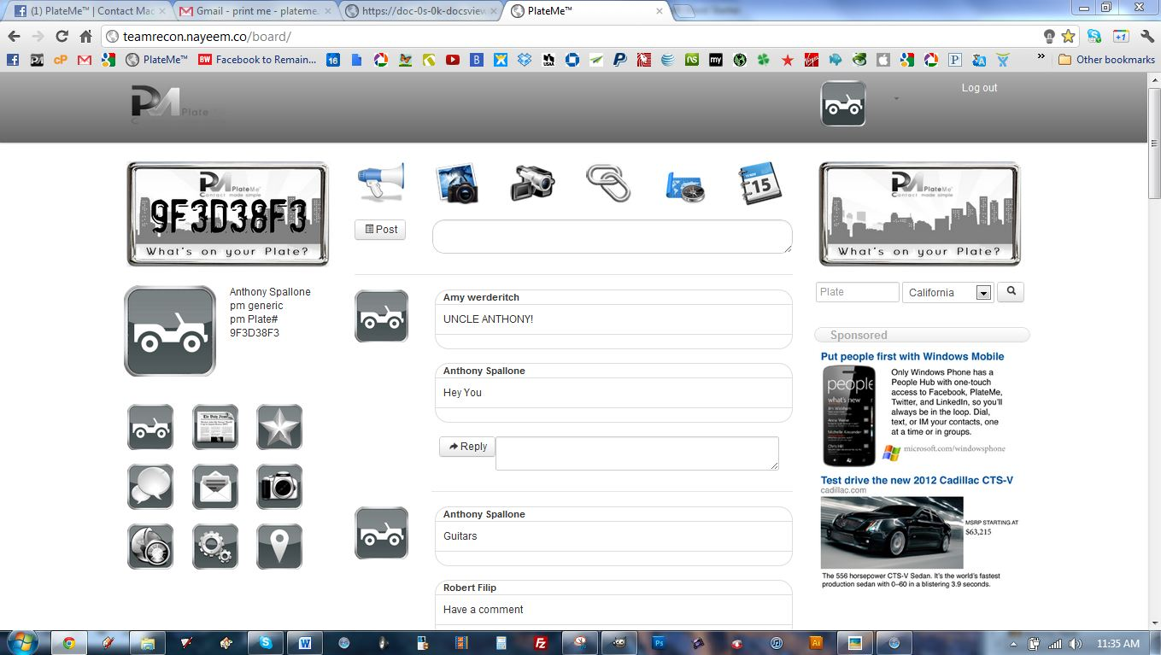

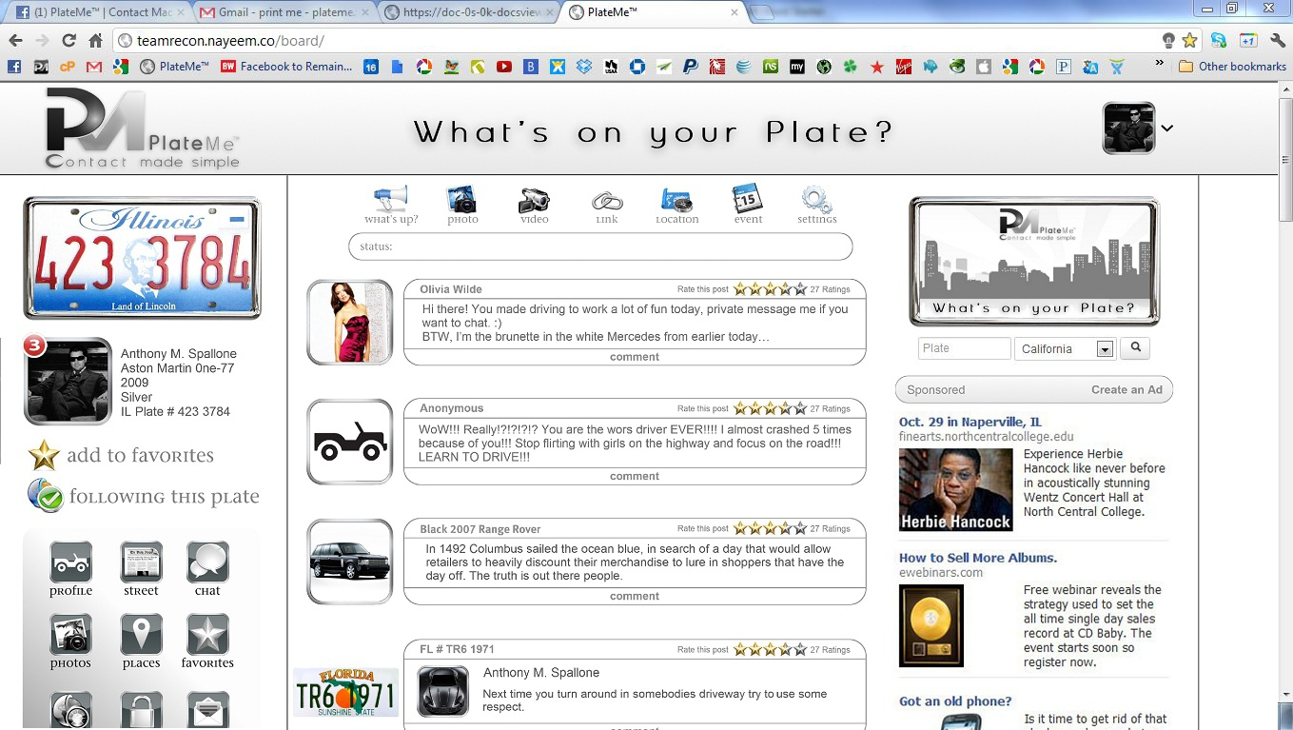

**Make Everything Look Exact to the Screen Shot Above**

**Profile Page**

1. **URL**
   1. Insert Favicon
   2. PlateMeTM | Contact Made Simple
2. **Header**
   1. Change header back to original
   2. Add “What’s on your plate?”
   3. Get all positioning correct
   4. Remove Log Out from top right – Where should the log out be?
   5. Scale Images / Logo’s / etc. properly
   6. Show number of notifications on top right of drop down menu profile picture
3. **Column 1** 
   1. License Plate
      1. Make Plate match Registration
      2. Update Plate Font
      3. Match Font Color with States
   2. Profile Picture
      1. Allow users to update their profile picture
      2. Keep Chrome Frame around all profile Pictures
      3. Match all information to the left of the profile picture
   3. Favorites These were there already, maybe need some clarification
      1. Add Favorites
      2. Pending Favorites
      3. Remove Favorites
   4. Followers Same as above
      1. Follow Plate
      2. Following Plate
      3. UnFollow Plate
   5. Navigation / Mobile Device Implementation
      1. Insert Bacground Shading
      2. Scale images with titles of buttons
4. **Column 2**
   1. Status Bar
      1. Scale and Structure Status Bar with Titles
      2. No “Post” button until “Status” bar is clicked
      3. Whats Sup?
         1. Make this work
      4. Photos
         1. Allow users to upload photos
            1. Multiple photos
            2. Tag
            3. Location
            4. Status with photo
      5. Videos
         1. Allow users to upload videos
            1. Tag
            2. Location
            3. Status with photo
      6. Links
         1. Allow users to post links
            1. Tag
            2. Location of Post
            3. Status with Link
            4. Link Preview
      7. Location
         1. Allow users to pull up maps (Google Maps is Fine)
            1. Allow users to check into locations
            2. Allow users to comment on check ins
            3. Allow users to search locations
      8. Events
         1. Allow Users to create events
         2. Invite Feature
         3. Location
         4. Time
         5. Event Title
         6. Event Description
         7. Photo
      9. Settings
         1. Drop Down of Additonal Settings
            1. Post As Anonymous
            2. Favorites Only
            3. Favorites and Followers Only
            4. Public
   2. Posts
      1. Allow Users to Post on Wall
         1. Display Users Profile Picture
         2. Display User Name | PlateNumber
            1. Anthony M. Spallone | 123ABC, IL
         3. Display Star Ratings
            1. Display How many people rated the post

Click number of people to view who rated comment

* + - * 1. Click stars to rate
      1. Display Time Stamp / Bottom Left
      2. Display Comment Button / Bottom Center
         1. Click to Comment
      3. Display Number of Comments Bottom Right
         1. Click to Expand
      4. When commenting on posts allow all same features as Status Posts.

1. **Column 3**
   1. Search a Plate
      1. Change License Plate to coincide with State Selection
      2. Allow all 50 states plus PM Generic Plate
      3. Use Real Time Photo Manipulation when searching a plate
         1. Update Plate Font
      4. Match Font Color with States
   2. Advertising
      1. Click Ad Bar to create an Ad
      2. Click Ad and have the link/video/photo hover over the current page

1. **Footer**
   1. Insert the 16 Languages we will be launching in
   2. Mobile – Pages – About – Advertising – Developers – Careers – Privacy – Terms – Help

|  |
| --- |
|  |

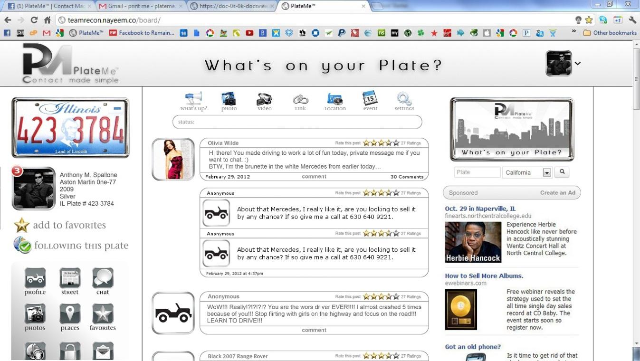

**Comments**

1. Comments
   1. Always Display last 2 comments
   2. Allow Star Rating on Every Comment
   3. Date Stamp all comments
   4. Click “30 Comments” to Expand and view all comments
   5. Make Comments look identical to above display
   6. Allow all post types in comments

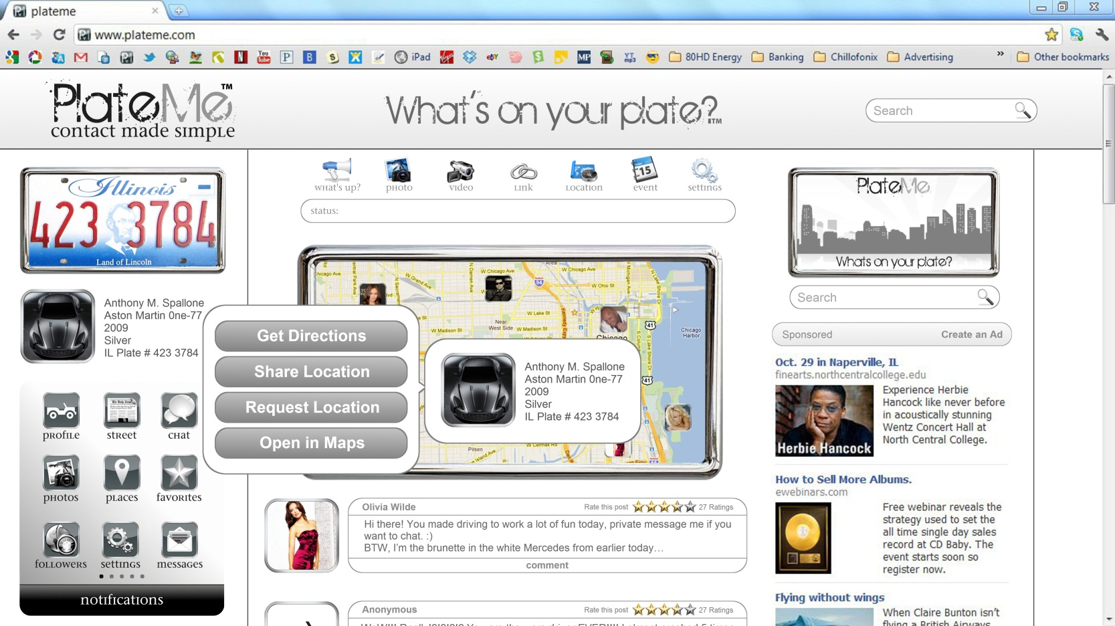

|  |  |
| --- | --- |
| |  | | --- | |  |   **GPS**   1. GPS    1. Link up to Google maps for       1. Directions       2. Open in Maps 2. Request Location & Share Location TBD |

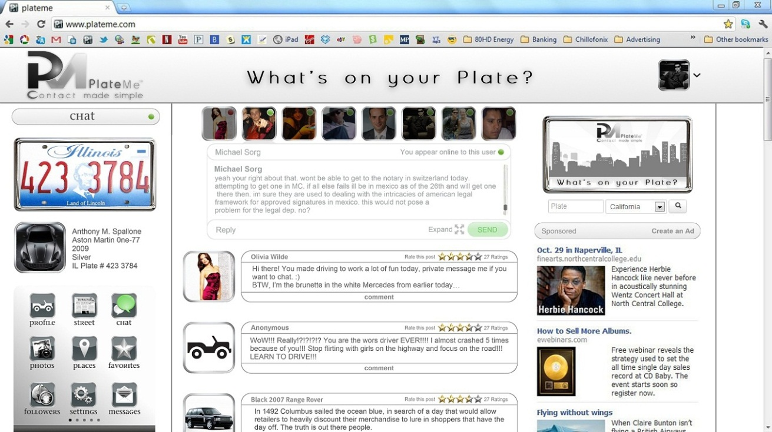

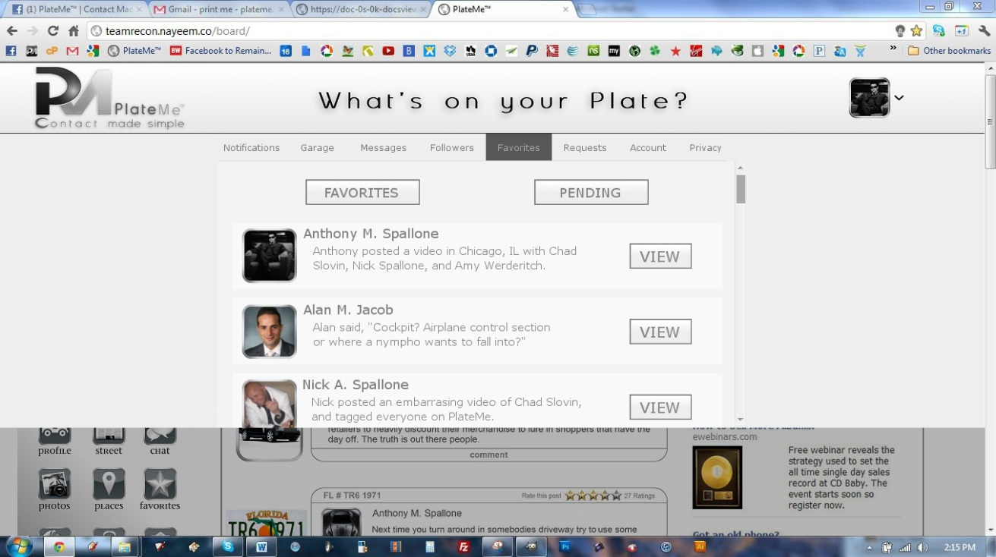

**Chat**

1. Get Chat Working as it appears above

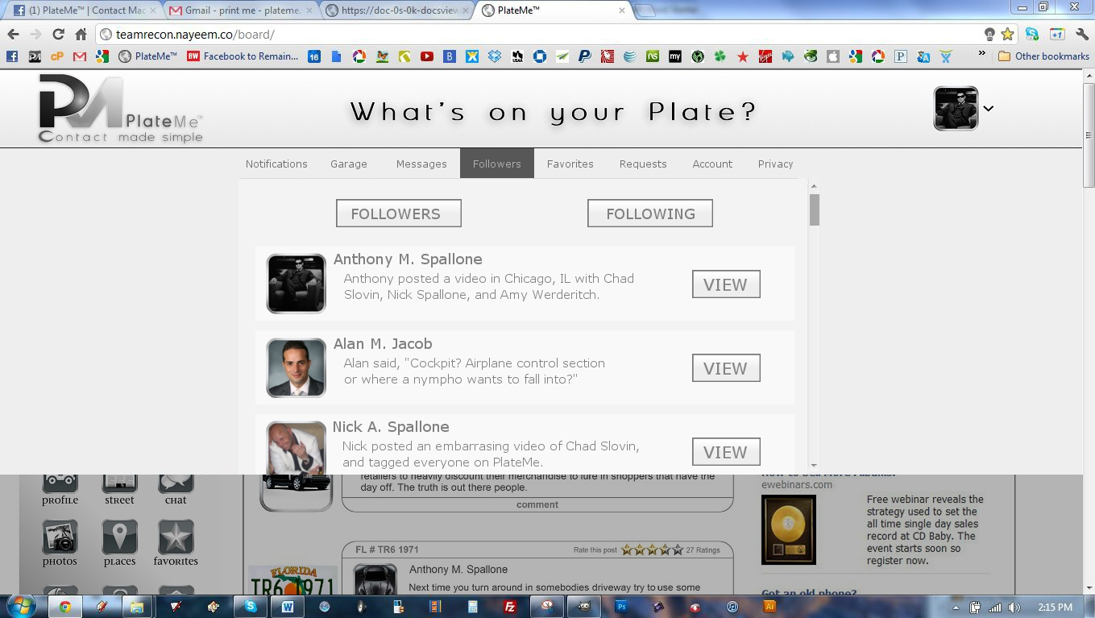

**Followers**

1. Get Followers Working as it appears above

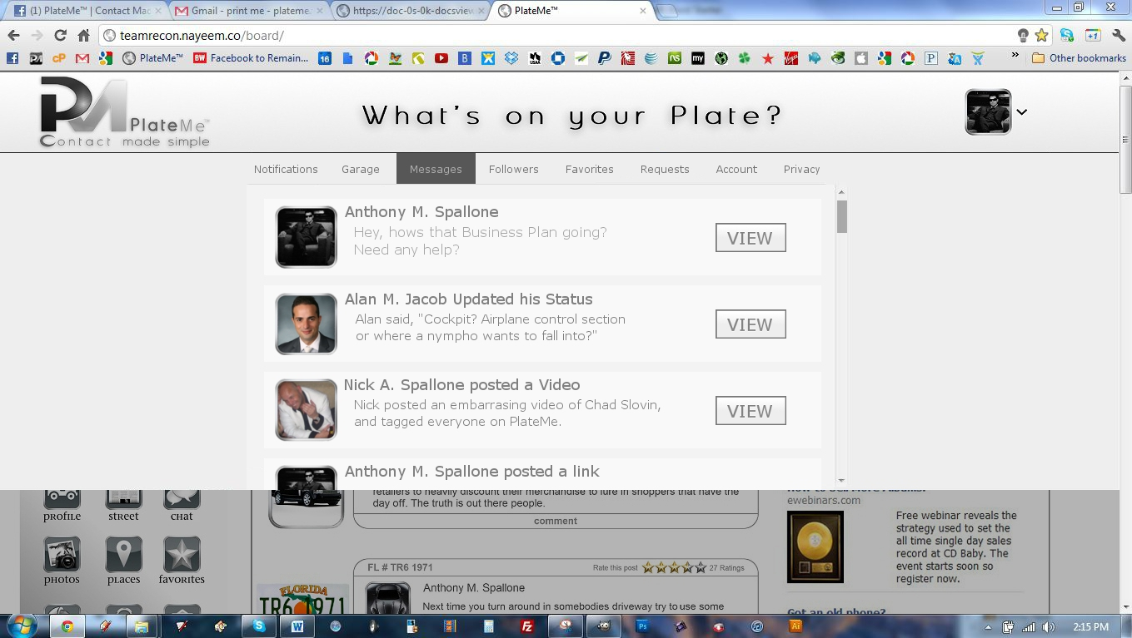

**Messages View**

1. Get Messages Working as it appears above

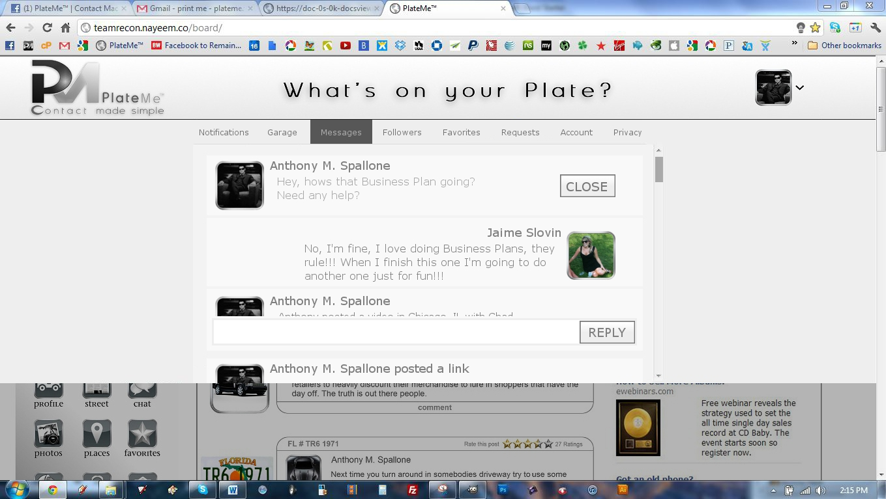

**Messages Reply**

1. Get Messages Working as it appears above

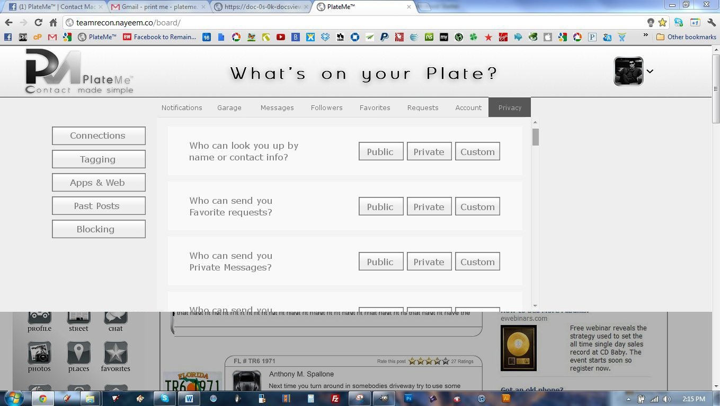**Privacy Settings**

1. Get Privacy Settings Working as it appears above

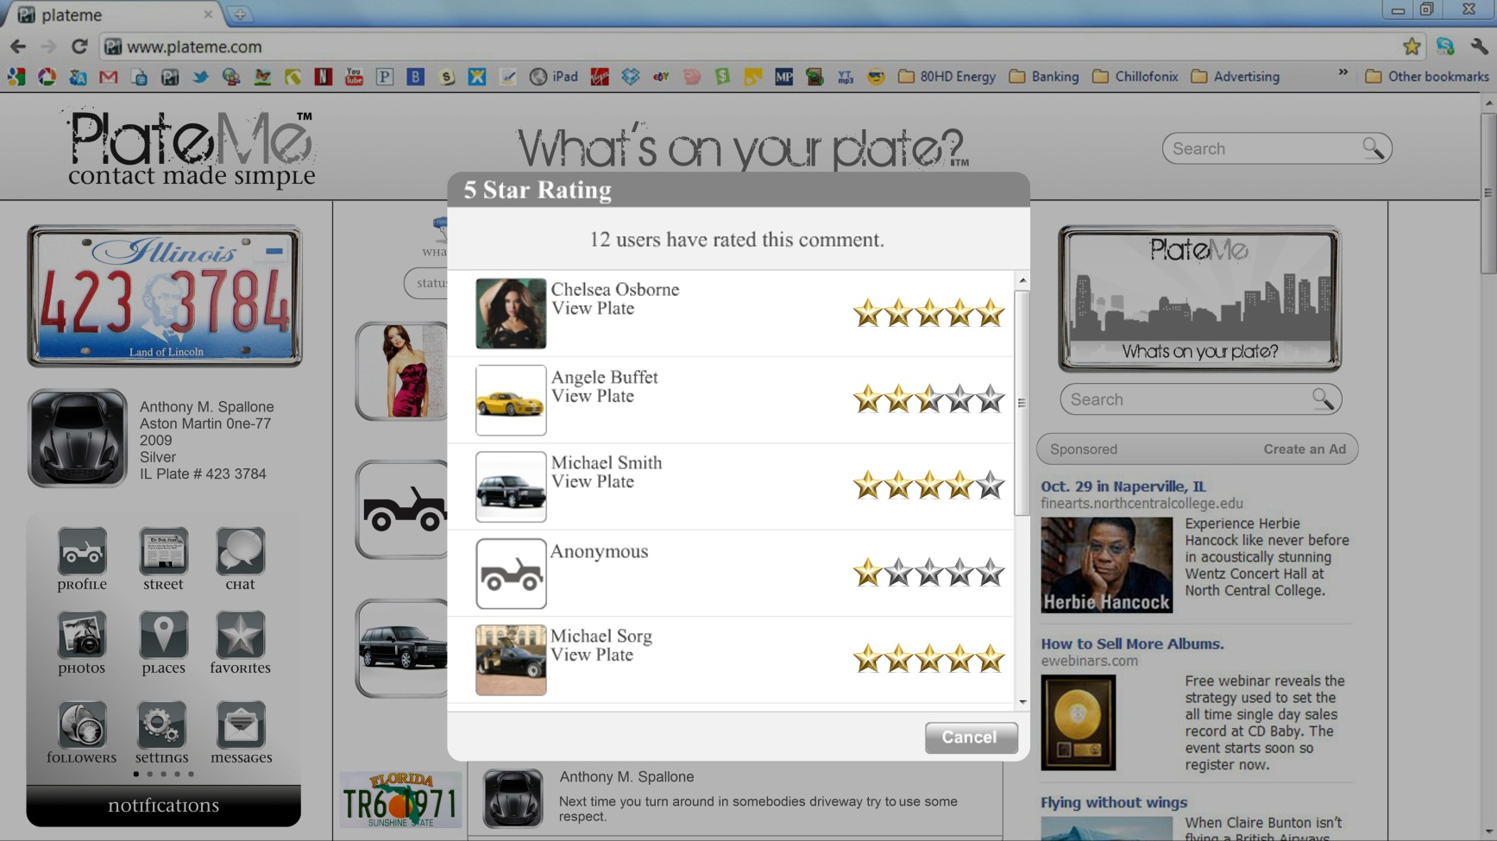

**Star Ratings**

1. Get Star Ratings Working as it appears above

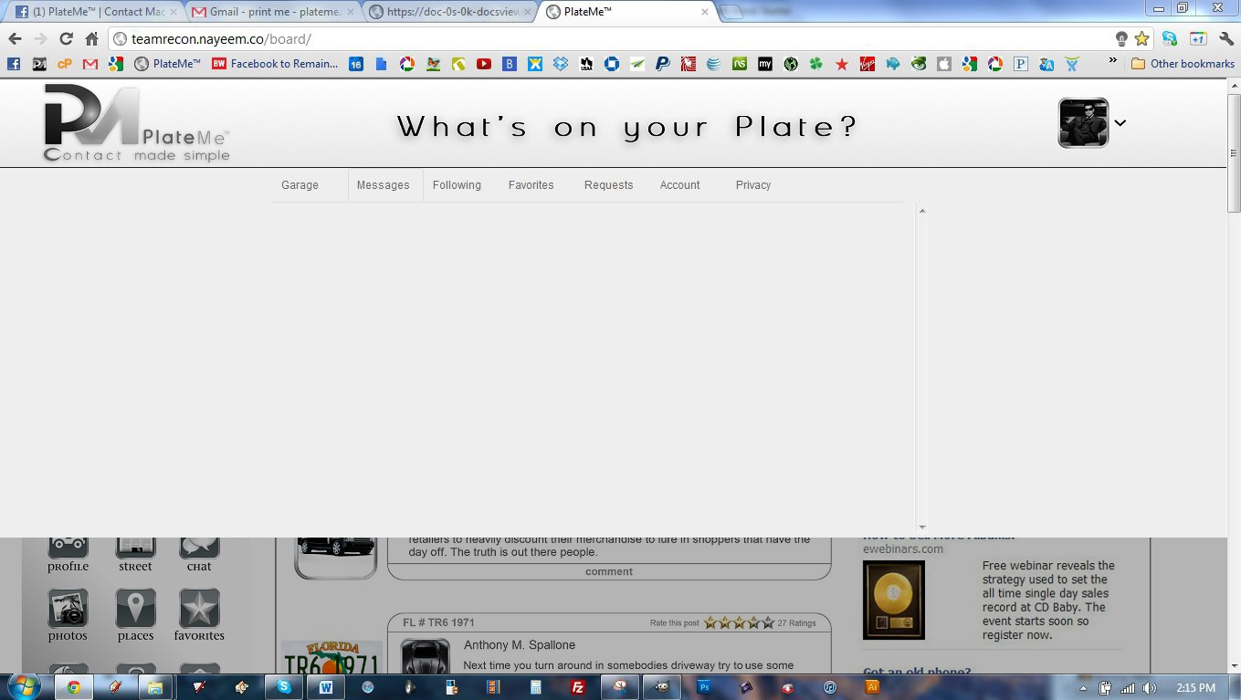

**Drop Down Bar**

1. Make drop down bar appear as is above

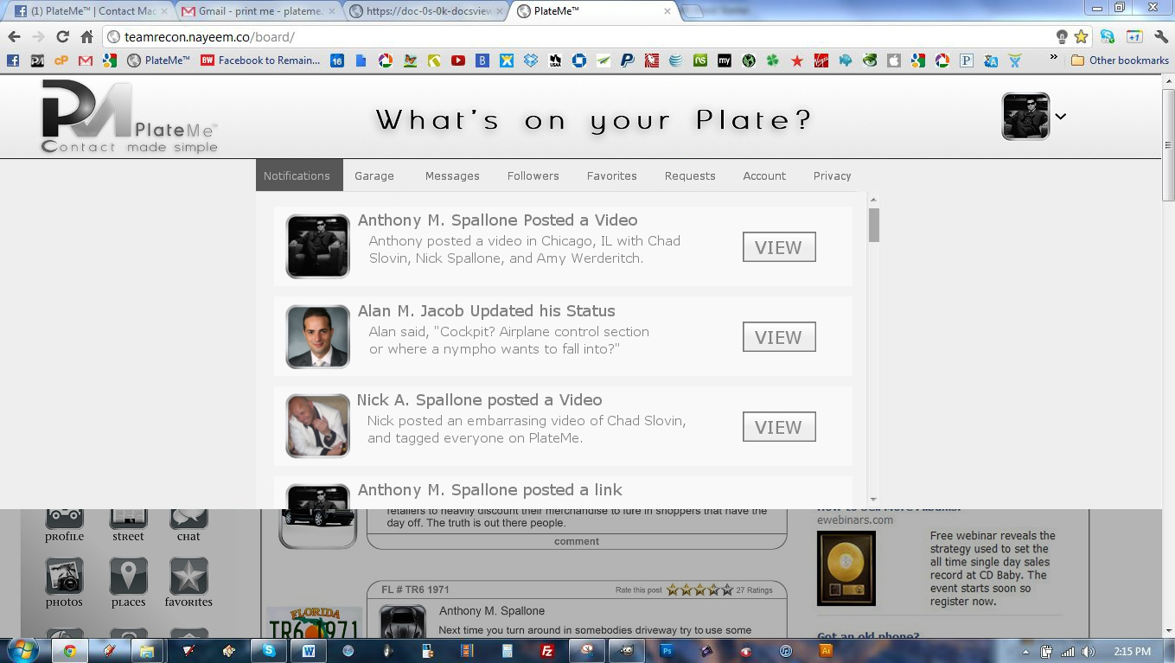

**Drop Down Bar - Notifications**

1. Make Notifications appear as is above



**Drop Down Bar – Messages I**

1. Make Messages appear as is above



**Drop Down Bar – Messages II**

1. Make Messages appear as is above



**Drop Down Bar – Followers**

1. Make Followers appear as is above

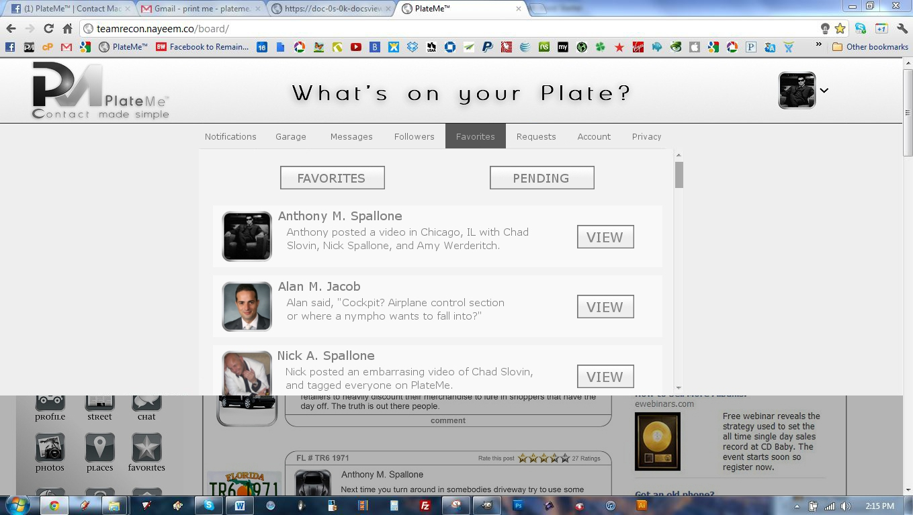

**Drop Down Bar – Favorites**

1. Make Favorites appear as is above

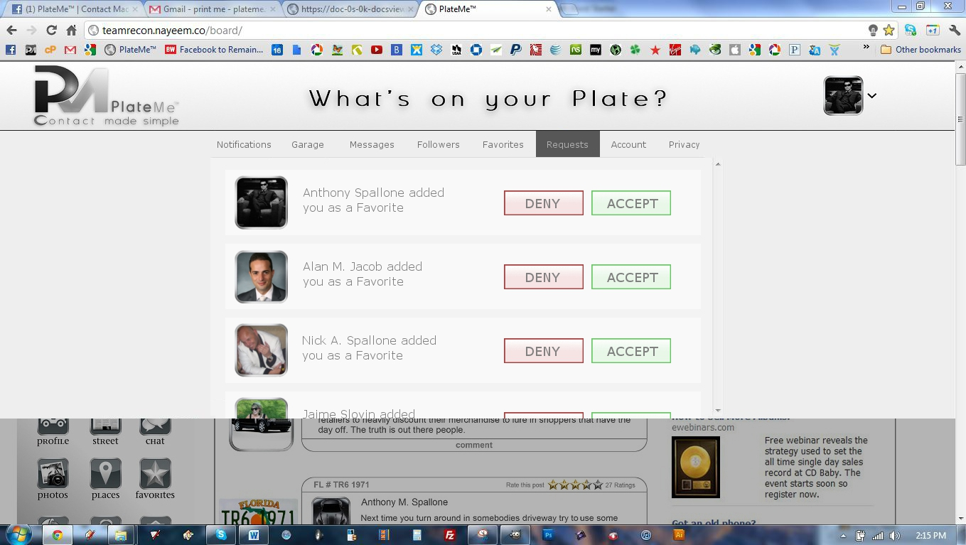

**Drop Down Bar – Requests**

1. Make Requests appear as is above

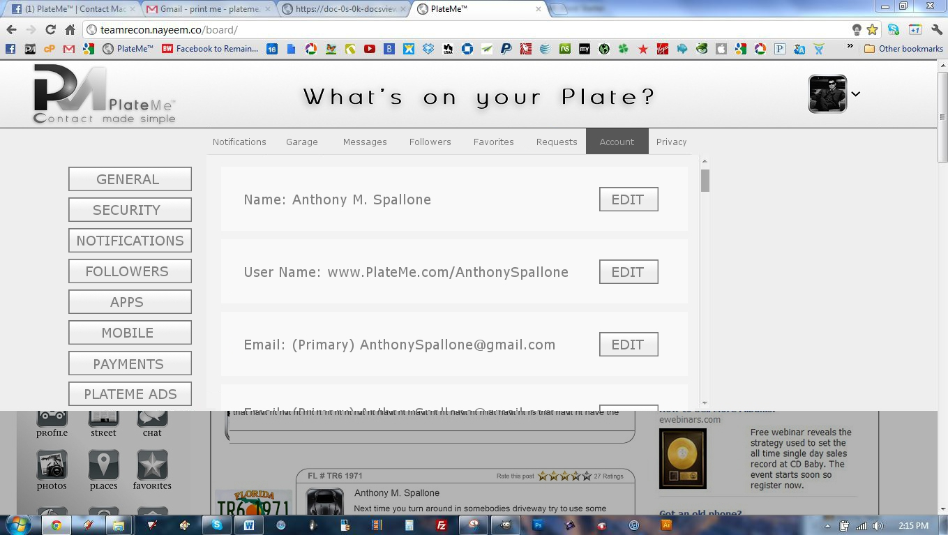

**Drop Down Bar – Account**

1. Make Account appear as is above



**Drop Down Bar – Privacy**

1. Make Privacy appear as is above